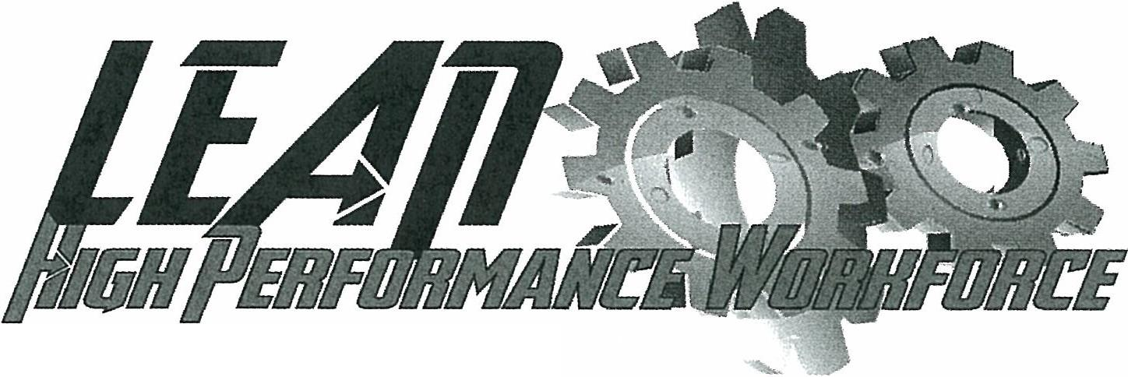
(

Since 1998 manufacturing in this country has been under at t ac k. Globalization, trade agreements, and corporate greed among other factors have contributed to the decline of U.S. manufacturing jobs. Our job security and our way of life have been and are being threatened!

We have developed a strategy that involves our members and helps the companies we represent to remain or become competitive, keeps manufacturing jobs in the U.S. and enhances our job security. IUE-CWA LEAN/ HIGH Performance is a means to accomplish this.

LEAN Manufacturing is not a new process, it was developed by Toyota from the 1950s to the 1980s and imported to the U.S. in the late 1980s. It is a method of organizing production to lower cost, eliminate waste, and improve quality. Typically, it was a process used by larger companies, but now we see much smaller companies adopting the process to try and stay competitive in today's global economy.

LEAN Manufacturing is not just another management participation scheme, but rather is a critical tool that companies are implementing to remain competitive in the global marketplace. It is an important tool to keep manufacturing jobs in the United States.

We understand that members are fearful of change and some perceive LEAN as a threat to their jobs. Employers also can be fearful of change and of the increased role the union can have in this process.

The version of LEAN/HIGH Performance that we have developed and support is one where we seek to change the awareness of LEAN, to train local unions on Lean Manufacturing and educate our employers on the benefits of Lean /High Performance. Ours is a process where the union has a role, where the employer listens to the employees, and one in which we can increase the skill and productivity to maintain decent jobs and wages. Through this process, we can increase job security and keep jobs in the U.S. The process has been tested and proven; we have saved jobs that would have been lost and added new jobs after "leaning" a facility.

How the Program Works

Many companies implement LEAN without preparing or educating our members or their managers on the process and expect everyone to be ready to accept change immediately. Our program is broken down into two parts, a change the culture piece and then the actual LEAN simulation. Our change the culture presentation introduces the workforce to the realm of change and covers the benefits of change. This class explores the employees' fears, their reluctance to get involved with the process, and also the need for change. We believe this to be a critical component to the success of our LEAN/HIGH Performance program because
(
our members as well as their managers need to understand why the company is interested in implementing a LEAN program.

The second part of our program introduces a discussion on the principles of the LEAN and participants are engaged in an actual LEAN simulation using the principles that they have previously been introduced too.

Additionally, the second part of our program offers workshops out on the floor, further teaching and reinforcing the principles of LEAN. These workshops are based on a need assessment that we develop from information gathered during the Lean /High Performance classes and information received from management and the local Union leadership. The workshops can include set up education, uptime, material flow and 6S (SS with Safety) to name a few. These workshops performed on the shop floor will involve both the operators and managers from that area. Building on the Lean principles taught in class, participants are encouraged to work as a team to improve their areas.

We have the ability to modify these presentations based on our assessment and your needs.

How to Get Started

Once an IUE-CWA Local is interested in pursuing LEAN/High Performance Workplace Program, they should fill out and submit the Initial Contact Form (a copy of the form is online at the IUE-CWA website. Once the Initial Contact Form is received, we will contact the Local to discuss the possibility of scheduling an initial visit to the location. During the initial visit we would need to tour the facility, meet with the Local Executive Board and the Plant Management Team (these meetings and be separate of together). During these discussions we will thoroughly explain our program, the required commitments, the costs and anticipated results, and respond to any questions or concerns.

After the initial meeting has taken place, if both parties are in agreement on moving forward we will contact you to discuss both your schedule and any needs to customize our plan to your facility.

If you have any questions about the program, please contact: Mike Mayes at Mmayes@iue-cwa.org

