To find per diem rates visit www.gsa.gov/perdiem
Type in either the State and City or the Zip code of the location you are traveling to and click Find Rates.
Use the results under Meals & Incidentals Breakdown to determine Per Diem for the trip.
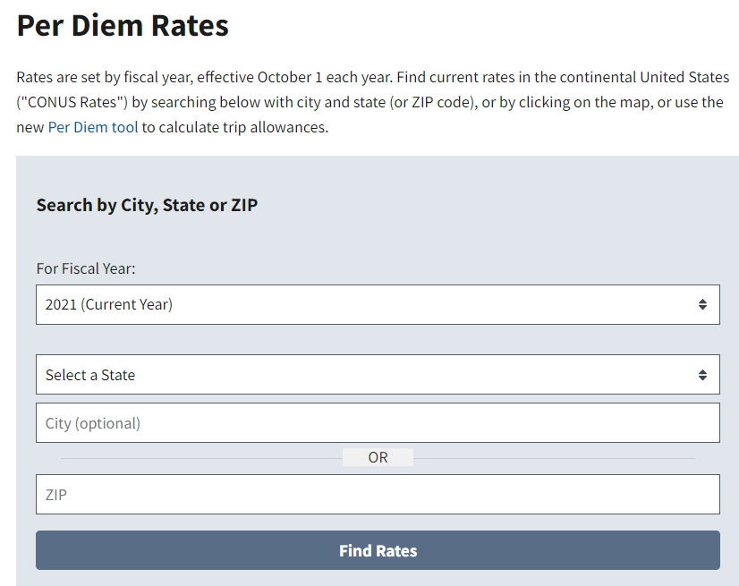
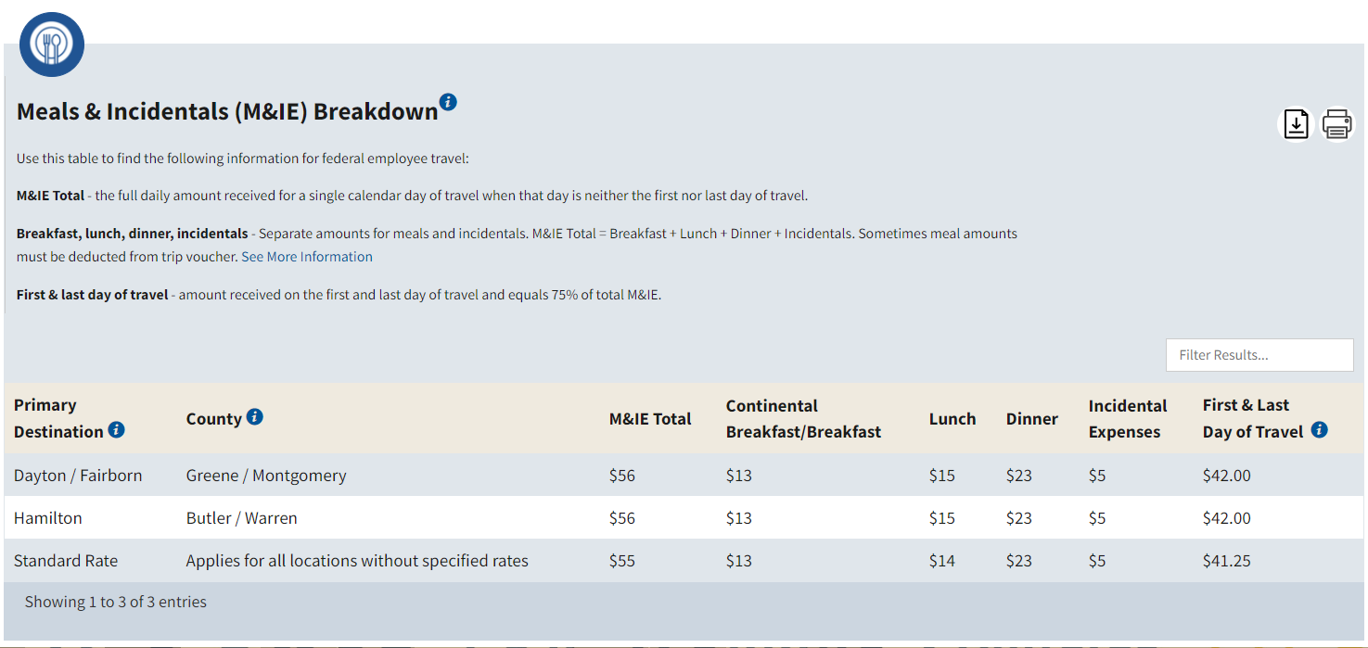

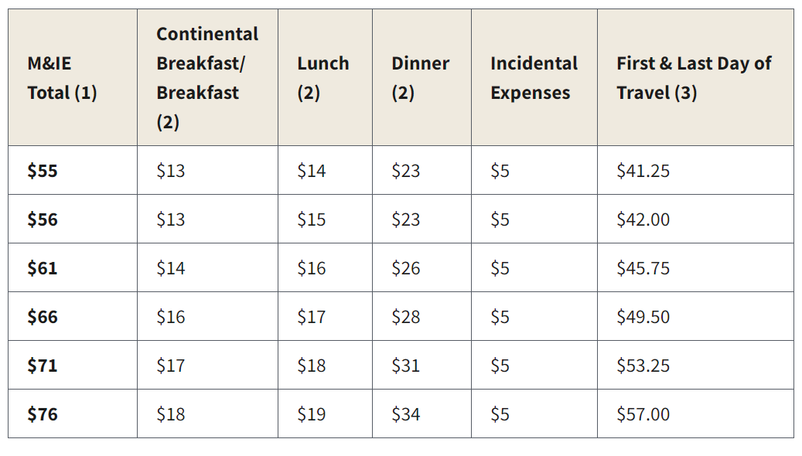

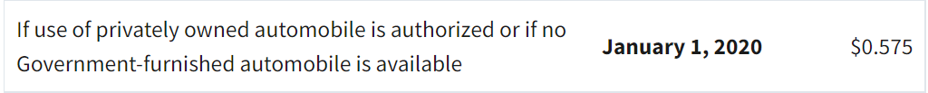

IUE-CWA
Lost Time and Travel Reimbursements

When a local officer or member is traveling on behalf of the IUE (or the IUE has agreed to cover some or all the cost of travel), our policy is for the local union to pay the member any lost time and/or expenses. The International will then reimburse the local upon receipt of the appropriate materials.
Locals will send all reimbursement requests to: Attn: Stacey Reynolds C/O IUE-CWA Headquarters, 2701 Dryden Rd., Dayton, OH 45439. If you are requesting reimbursement under a SIF (SCA members, Mentorship program, Political Training, Health and Safety, CWA Strong, National Women’s Program, Diversity e.g.), the check your locals receive will come from CWA HQ in Washington, DC. Checks from Washington can take up to two weeks.

REQUEST FORMAT

Requests for reimbursement for lost time and/or travel expenses should include copies of all receipts/substantiating materials stapled to a subtotal sheet which lists the travel and lost time amounts the local is requesting for each member (one subtotal sheet with receipts attached for each member).
Also include a brief cover letter to the International asking for the total amount to be reimbursed to the local and naming the person(s) who have traveled on our behalf and for what program. (See attached examples)

LOST TIME

Each time the local sends a request for lost time for a member who has traveled to an IUE-CWA Event or done work on our behalf, the International needs three things in order to reimburse the local for lost time.

    - We need a copy of the check written to the member for lost time. (REMEMBER—lost time MUST be paid as payroll. Locals cannot write members a non- payroll check for lost time.) The International will reimburse the Local for the Gross amount of the payroll check written to the member PLUS the local can request the employer share of social security and Medicare (7.65% of the gross).
    - We also need either a lost time report from the company showing that the member “lost” the time or a copy of the member’s paystub from the employer which shows that they “lost” the hours from their normal pay. The paystub also substantiates the hourly rate of the employee.
    - Copy of the local Lost Time Voucher
** Locals should never write a lost time check for any reason without some substantiation that the member was NOT paid by the employer.

*Note—Per CWA policy, we do not reimburse for lost overtime. We also do not pay “lost time” for travel on weekends.
TRAVEL EXPENSES

Per CWA regulations, receipts are required for ALL meal and travel expense reimbursements. Even if your local pays per diem and does not require receipts, to get reimbursed from the International, you MUST send in receipts. Also, meal reimbursements for any given day may not exceed the IRS Per Diem amount for the city traveled to. Also, please note that per diem for travel days is LESS than per diem for days spent at the destination city (see the example and chart on the attached sheet). For more information, go to www.gsa.gov/perdiem)

If the Local pays per diem in advance to the member for travel on behalf of the International, the member may need to reimburse the local part of that per diem amount upon return from the trip. When meals are provided by the International (and some meals almost always are), if members received per diem for that day, the per diem amounts for those provided meals must (by Federal Law) be reimbursed by the local member to the local. Members cannot keep per diem amounts for meals they did not pay for and the International will not reimburse locals for per diem amounts for meal we provided to members at our expense.
How can you avoid paying members too much per diem prior to the trip? First, you can carefully read the call letter. We generally note on the call letter which meals will be provided to the members. You can back the IRS Per diem amount for those meals out of the per diem you pre-pay the member prior to the trip.
For example, The trip is to Las Vegas for four days (including two travel days) and the daily per diem amount is $45.75 for each of the two travel days and $61 for each of the two days in Las Vegas. Per the call letter, the International is providing breakfast, lunch, and dinner on one day in Las Vegas, just breakfast and lunch on the second day, and no meals on the two travel days. Using the attached chart, you would take the per diem amount for four days ($61X2=$122 and $45.75X2=$91.50) which totals $213.50 and subtract one full day of meals ($56) and one day of breakfast and lunch ($30). You would then write the per diem check to the member for $127.50.
Note that the International will NOT automatically reimburse that final amount to the Local. The International will only reimburse to the Local the amount of the actual itemized meal receipts the member turns in. Does the member owe the Local back the difference between the IRS Per diem amount allowed and the amount of the actual meal receipts? No, but the Local will incur the cost of the difference.
If the local is not willing to incur the cost difference between IRS Per diem allowed and actual meal receipts turned in—the local can simply have the member use his/her own money upfront for travel on behalf of the International and can reimburse the member for receipts turned in after the trip up to the IRS per diem amounts allowed (the same exact amount the International will reimburse the local).
INCIDENTALS

The IRS Allowed Per diem amount includes $5 a day ($3.75 a day on travel days) for incidentals without a receipt. The International will also reimburse the $5 for incidentals with no receipts, but an explanation of the expense must show on the summary sheet the local submits to the International for reimbursement. (For example: $3 tip to maid and $2 tip to the baggage handler).

AIRFARE POLICY

On some occasions, the International IUE-CWA will set up a procedure for members to call AAA Travel, and in that instance, the International will directly pay for the airfare. When that is not an option, the member/local will purchase their own reasonable airfare and be reimbursed by the local. The International will only reimburse for coach airfare, and every effort must be made by the local/member to keep the cost of the airfare down. The International will not reimburse for airfare that is deemed unreasonable. The International will also pay for one checked bag per member each way. Taxi fares to and from the airport are NOT included in per diem and will be reimbursed with a receipt.
Note: We do not require members to fly on prop airplanes even if a regional jet is slightly higher.

DRIVING

A google map or equivalent must be turned in showing the starting and ending points of travel with total mileage.
If the cost of mileage is equal to or less than the cost of a typical/reasonable airline ticket to the destination, the member may choose to drive to the location and be reimbursed mileage (mileage rates change each year and can be found on the IRS gsa.gov/travel website) The mileage amount reimbursed includes fuel and wear and tear on the vehicle. Gas receipts showing that the member drove must be submitted when the local requests reimbursement for the mileage amount. When requesting mileage, you cannot receive reimbursement for fuel. The International reserves the right to require members to drive to destinations that are within a reasonable distance from the member’s home.
**Important—If two or more members drive together to a destination, only the person actually driving their personal vehicle will get mileage reimbursement. Requesting or receiving mileage payments for riding as a passenger in someone else’s car is against the law.
Required Reimbursement Documentation

Lost Time:
- Copy of paystub showing lost time and rate of pay (or employer weekly lost time report)
- Copy of the local lost time voucher
- Copy of check from local issued to member for lost time
**All three items for lost time must be submitted each time for each person**

Expenses:

- Copy of the local expense voucher
- Copy of the check issued from the local to member for the expenses
- Meals: Copies of all itemized meal receipts and final receipt (showing the tip)
- Incidentals: (tips: housekeeping, etc.) no receipt required but must notate on reimbursement request date and amount
- Travel Expenses: Copies of all other travel expense receipts- baggage fee, taxi, tolls, parking, etc.
- Mileage: Either a google map or map quest showing the start and finish destinations
**Copies of checks written from the local to the member for reimbursement and local expense vouchers must be submitted each time for each person**

Reimbursement Summary Sheet that includes:
Local Number
Meeting Name and Date
Attending Members Name
Total Reimbursement Request- Lost Time Amount and Expenses Amount
Contact name, phone number, and email address of person at local submitting reimbursement request
All reimbursement request must be received no later than 90 days of the last day of travel to be eligible for reimbursement. No exceptions!
Please remember that we do not require the original receipts submitted to the International—Only copies. It is important that the local keeps copies of all receipts and the expense vouchers at the local.
All Reimbursement request are to be submitted to Stacey Reynolds
Email: sreynolds@iue-cwa.org
Mail: 2701 Dryden Rd, Dayton OH 45439
Fax: 937-298-2636
SAMPLE REIMBURSEMENT REQUEST
June 13, 2020

IUE-CWA Headquarters
Attn: S Reynolds
2701 Dryden Rd.
Dayton, OH 45439

Please find enclosed summary sheets totaling $1,820.94 for lost time and travel reimbursements owed Local 8XXXX for travel by John Smith, Joe Green, and Lisa Johnson to the Health and Safety training meeting in Chicago on May 3-6 of this year.
All receipts for each member and copies of their Local lost time payroll vouchers and paystubs showing time lost are attached to the summary sheets.

John Smith’s total is | $602.40
Joe Green’s total is | $590.13
And Lisa Johnson’s total is | $628.41
Total: | $1,820.94

If you have any questions, please contact our financial secretary, Greg Jones at (777)555-2222.

In Solidarity,

Jill Simmons
President Local 8XXXX

Local 8XXXX Reimbursement Summary Sheet

John Smith, Travel to Chicago Health and Safety Training: May 3-6, 2020

Lost time (see attached payroll voucher and copy of employee paystub)
2 days X $200 = $400.00 ($25/hr)
Meals for three days of travel (amount equals receipts attached) $167.40
Incidental amount for three days of travel = (no receipts required) $15.00
Total to reimburse the Local for John Smith: $582.40

